Step 1:

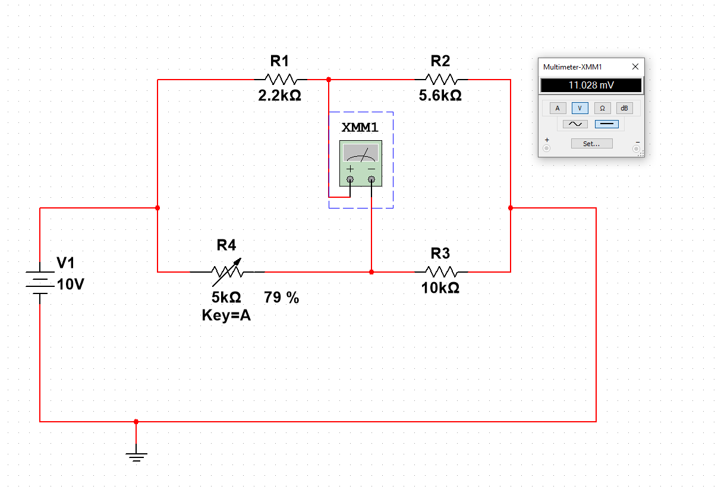

Step 4:

Rx/Rk = R2/R1

Rk = (Rx\*R1)/R2

Rk = (10 \* 2.2)/5.6 = 3.929 kOhm

In the circuit simulation, the closest that Vab got to 0 V was when Rk was equal to (0.79 \* 5), which is equal to 3.95 kOhm.

Percentage difference between measured and theoretical Rk:

(3.95 - 3.929)/3.929 \* 100 = 0.534%

Step 5:

Measured value of Rx

Rx = (R2/R1)\*Rk = (5.6/2.2)\*3.95 = 10.055 kOhm

Step 6:

Percentage difference between measured and theoretical Rx:

(10.055 - 10)/10 \* 100 = 0.55%

Step 10:

PR1 = [V0/(R1 + R2)]^2\*R1 = [10/(2200+5600)]^2 \* 2200 = 3.616 \* 10^-3 W

PR2 = [V0/(R1 + R2)]^2\*R2 = [10/(2200+5600)]^2 \* 5600 = 9.204 \* 10^-3 W

PRk = [V0/(Rk + Rx)]^2\*Rk = [10/(10000+3929)]^2 \* 3929 = 2.025 \* 10^-3 W

PRx = [V0/(Rk + Rx)]^2\*Rx =[10/(2200+5600)]^2 \* 10000 = 5.154 \* 10^-3 W

PT = PR1 + PR2 + PRk + PRx = 1.999 \* 10^-3 W